Cadorna, Joeffrey September 4, 2025
BSCS – 2 (CBM)
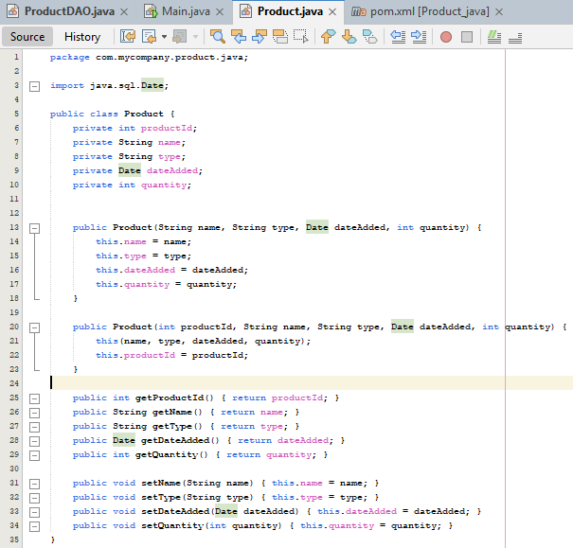
Product

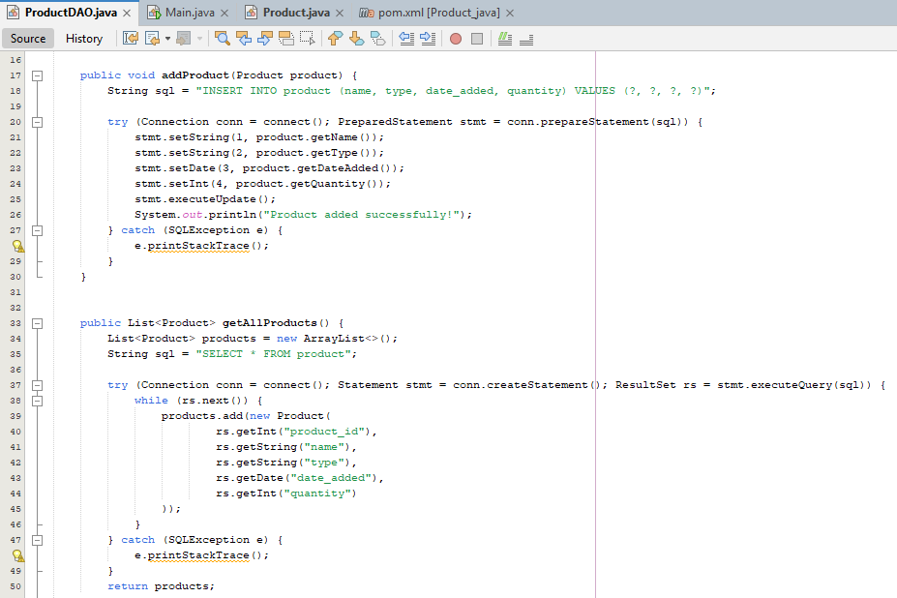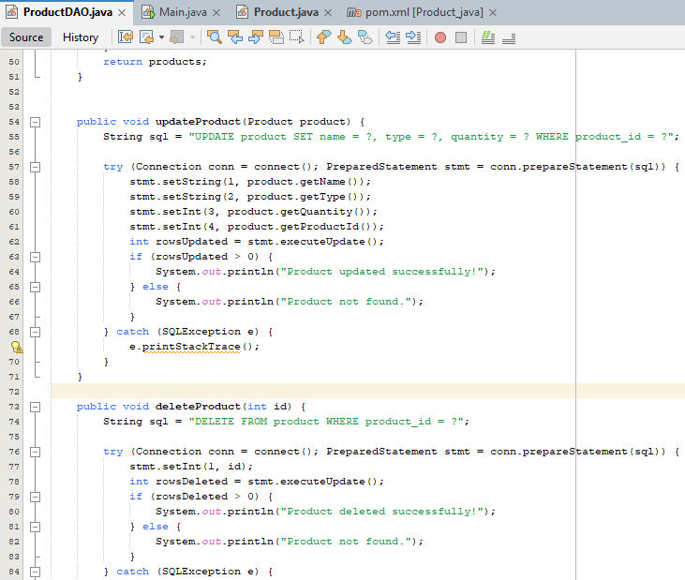
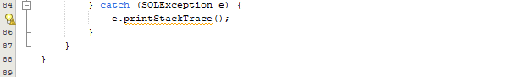
ProductDAO

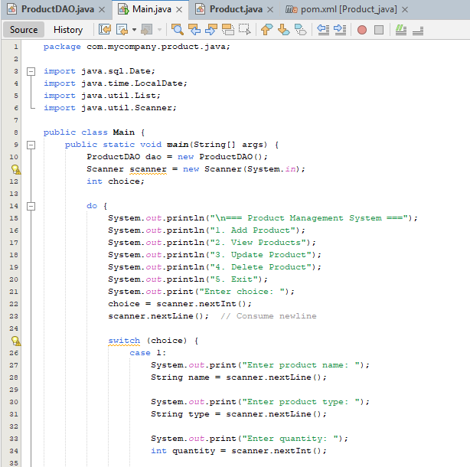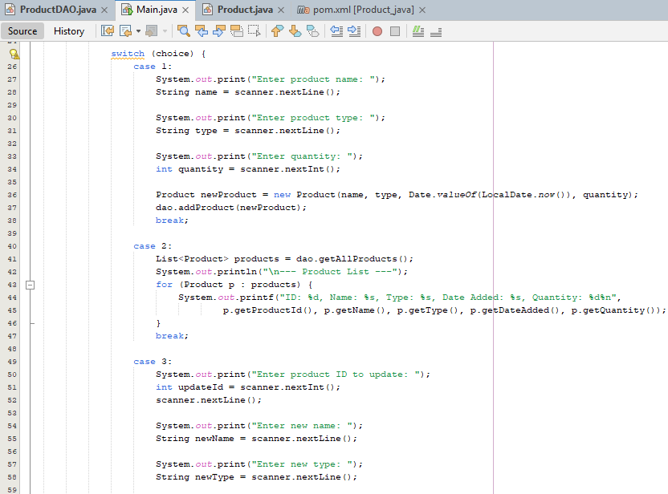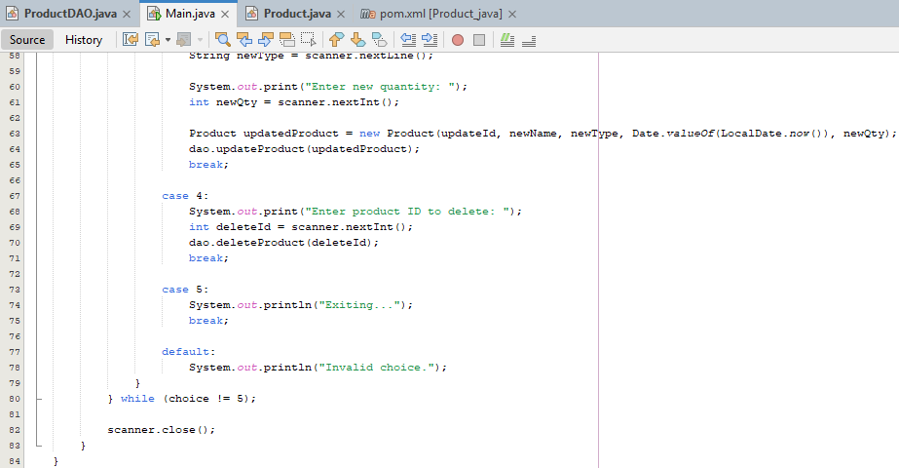
Main

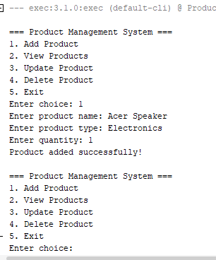
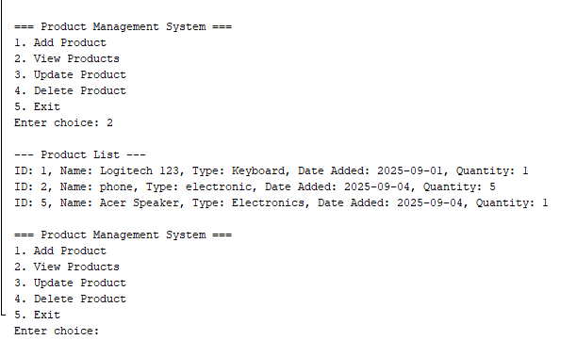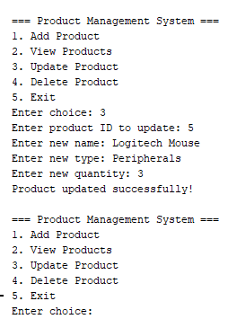
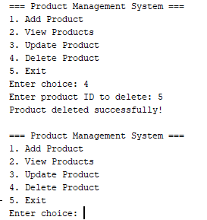
Output

The code consists of three main files: ProductDAO.java, Main.java, and Product.java.
1. ProductDAO.java – This file handles database operations related to the product table.
addProduct(Product product): This adds a new product to the database given with details such as name, type, and quantity of the products added.
getAllProducts(): This retrieves a list of all products from the database.
updateProduct(Product product): This updates the details of a specific product by the existing product ID.
deleteProduct(int id): This deletes a product from the database by its ID.
For the Database Connection, I have utilized JDBC to connect to the MySQL database. Then for the SQL Queries, I have utilized the INSERT, SELECT, UPDATE, and DELETE.

2. Main.java – This file is the main application that interacts with the user and allows them to perform the CRUD operations on the products they wish to select or interact with. Moreover, on the User Interface or UI, there is a console-based menu with the following options:
  - Add Product: Prompts the user to enter product details (name, type, quantity) and adds the product to the database.
  - View Products: Displays a list of all products from the database.
  - Update Product: Allows the user to update a product's details by entering its ID, thus further modifying any changes to the specific or particular product.
  - Delete Product: Prompts the user to input a product ID to delete by entering the product ID.
  - Exit: Exits the program.
Then, the program runs in a loop (via a loop statement) until the user chooses to exit, continuously showing the menu and handling user input.
3. Product.java – This file on the other hand, represents a product entity with its properties and methods of the following:
Fields:
productId: Served as a primary key or unique identifier for the product.
name: Name of the product.
type: Type/category of the product.
dateAdded: The date when the product was added to the inventory or database.
quantity: The number of units in stock.
Constructors:
There is one constructor that takes the name, type, date added, and quantity. While the other constructor takes the product ID, together with the other properties of the product.
Getter and Setter Methods: These methods allow the retrieval and modification of the fields of the product.

